# Assignment 5

## Intro

For this assignment we used our modification of Josh’s simulation code on informational openness in a cooperative IGT. We retain the symmetrical knowledge condition and the confidence sharing method of making group decisions from Josh’s earlier work. We then add a feature that weights the information provided by agents for the group decision, based on how well they have performed earlier. We expect this to overall increase the performance of the agents in the group, but also slightly in general because it might allow the agents to quicker learn which decks are good choices. Thus, the hypotheses:

## Hypotheses:

* Mean value per trial increases in the performance weighting condition
* Mean value per trial increases in the confidence sharing condition
* Performance rating results in a greater advantage of joining the group

## Model

The model used for the analysis can be written as:

Where V is the mean value per trial across all agents and trials per simulation, P is the presence of performance weighting and C is the presence of confidence sharing in group decisions. denominates the intercept for the value, and the effects of performance weighting and confidence sharing, respectively, and the interaction effect between performance weighting and confidence sharing. then is the error term. The *s* subterm denotes the presence of a random effect per simulation.   
We also use a simpler model without the interaction.

The outcome variable has been scaled and centred.

The model is run with 5000 iterations of which 2000 are startup, using the brms package.

## Priors

For the intercept we use a broad normal prior with mean 0 and standard deviation 1. For the model deviance we used a Cauchy distribution with x0=0 and gamma=2.  
We have used two sets of beta priors for comparison. For relatively loose priors we have used normal distributions with mean 0 and standard distribution 0.1 for all beta values. For the stricter priors we have used normal distribution with mean 0 and standard distribution 0.01.

## Model Results and quality check:

### Loose Full Model

Below is the output of running the model with the more broad priors

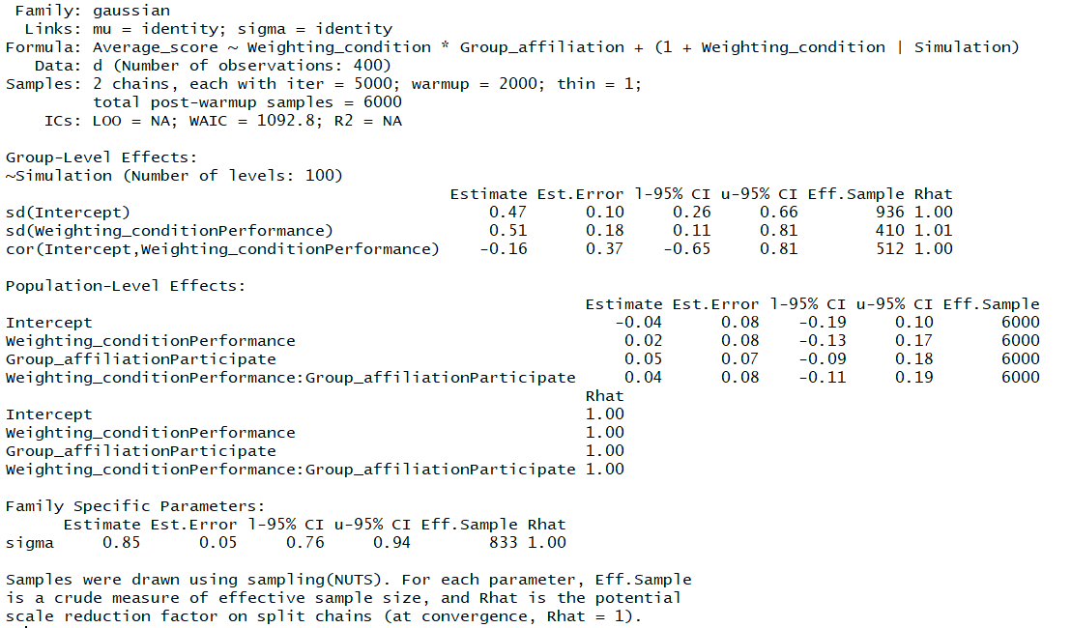

And the plots of the estimate distributions:

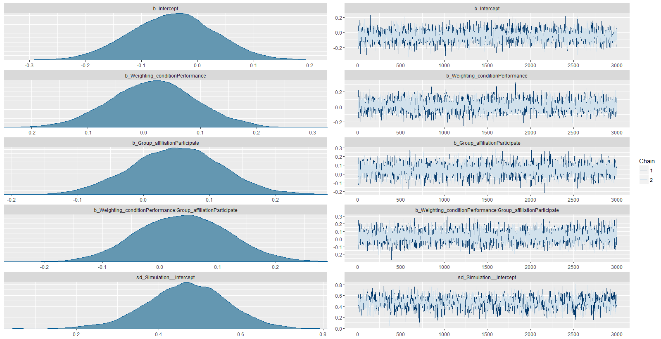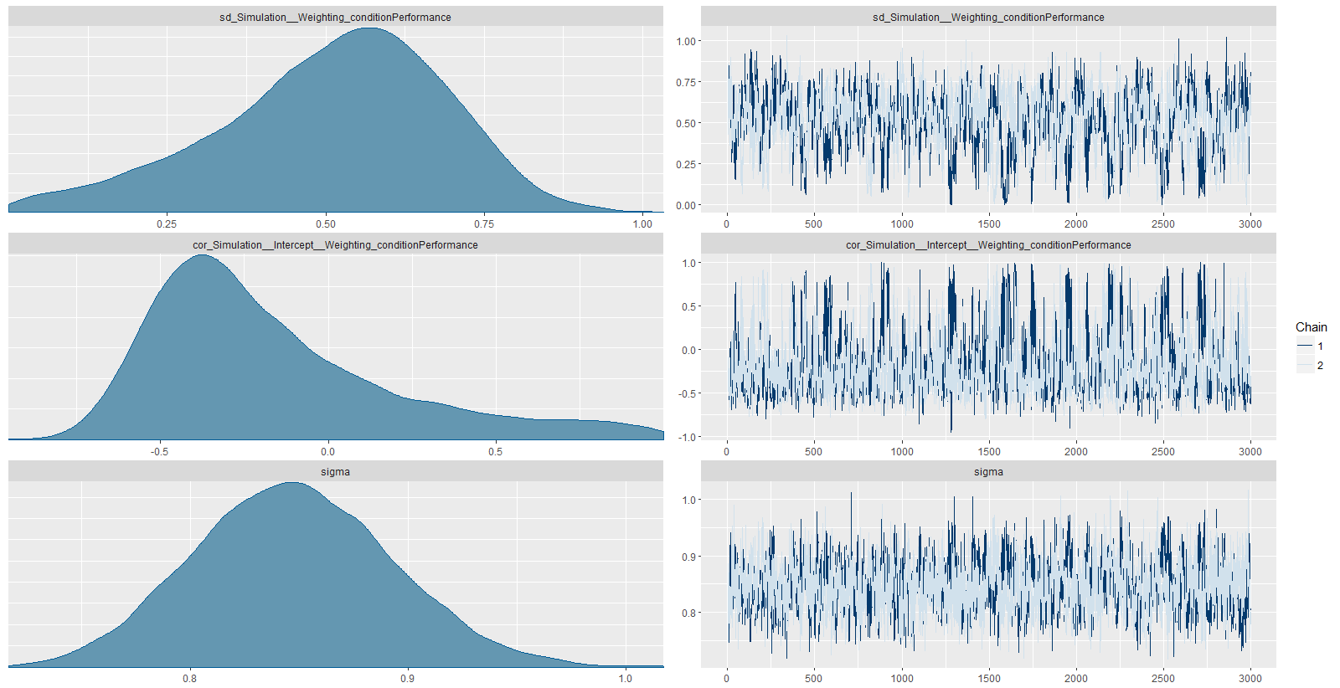

It can be seen that there is a negative intercept, and that all beta estimates are above zero, which fits the hypotheses, although with very broad distributions. There is a fairly large spread in effect sizes across simulations, and there is a large uncertainty overall.

Below, the predictive posterior check show that the model predicts the data fairly well, although slightly missing a peak and some of the left side:

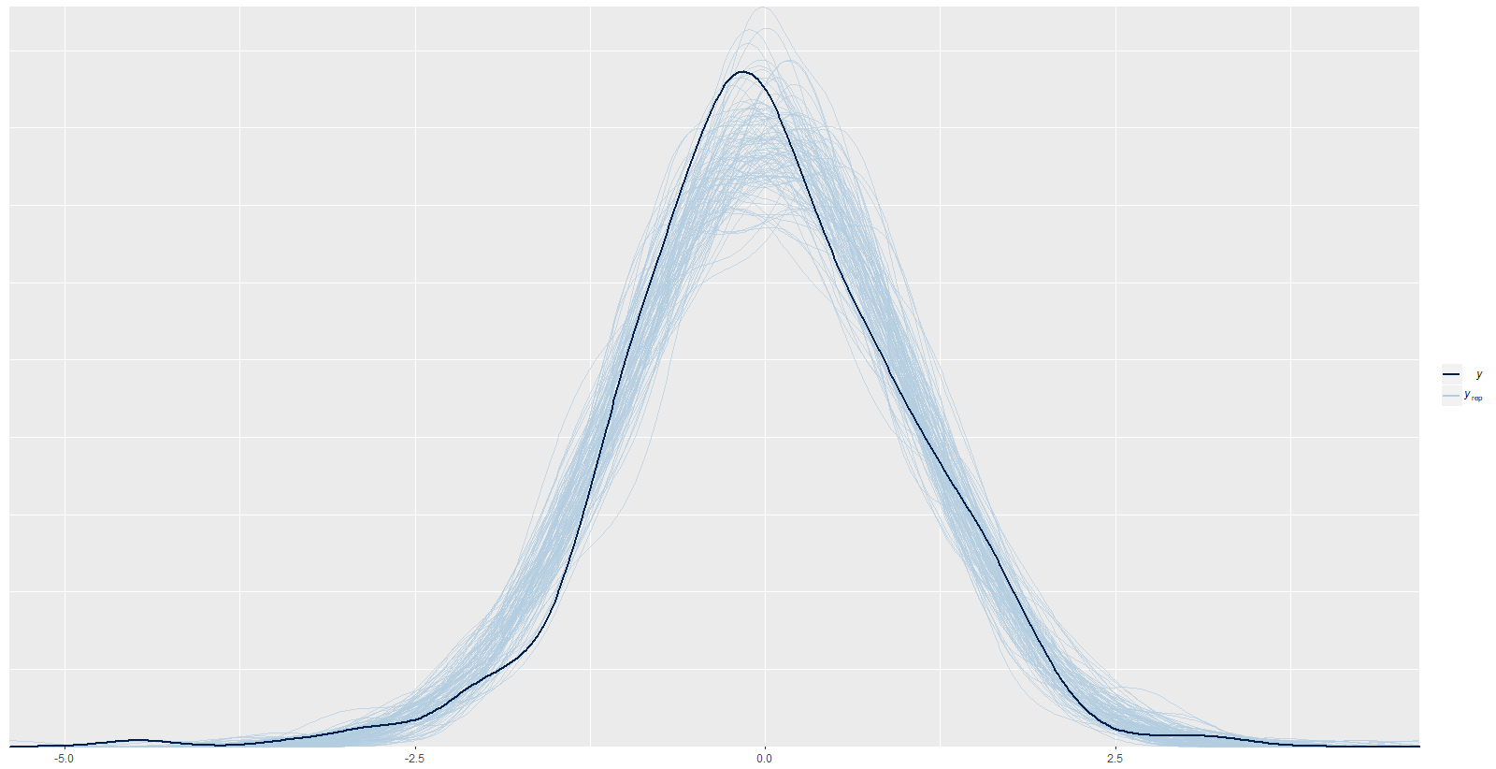

### Strict Full Model

Again, the numerical output and plots of estimate distributions for the model using narrow priors:

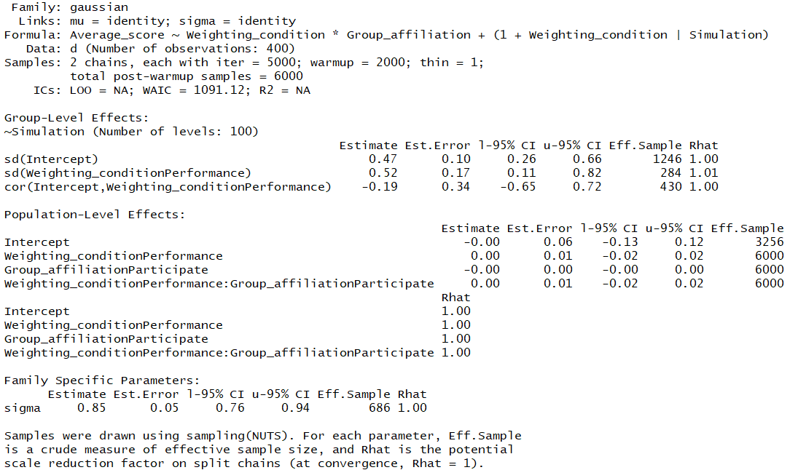

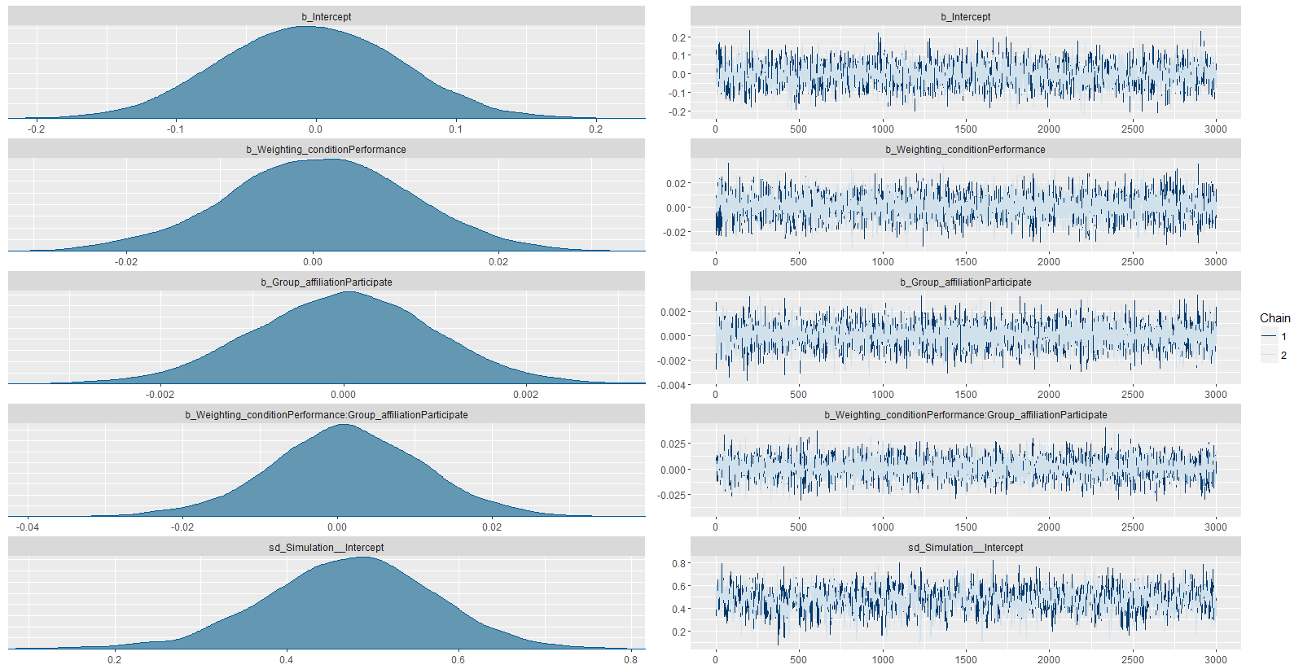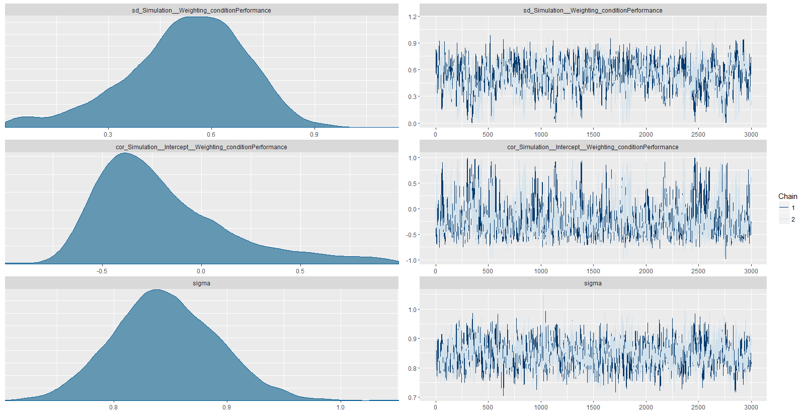

Here, all beta estimates and the intercept are centered around 0, which is also reflected in the numerical output. There are comparably large random effects, and variance overall.   
From the predictive posterior check plot below, the performance does not seem to have changed much – both models perform comparably well.

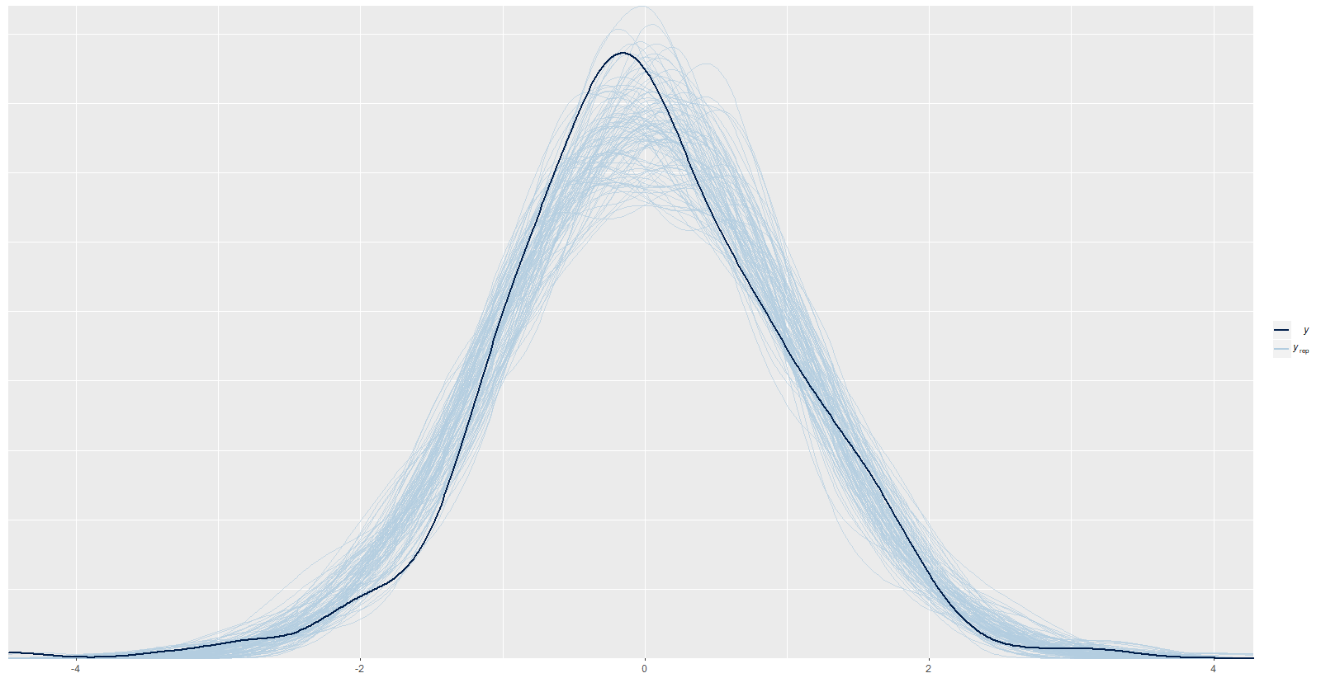

### Loose Simple model

Numerical output and estimate distribution plots for model without interaction and loose priors:

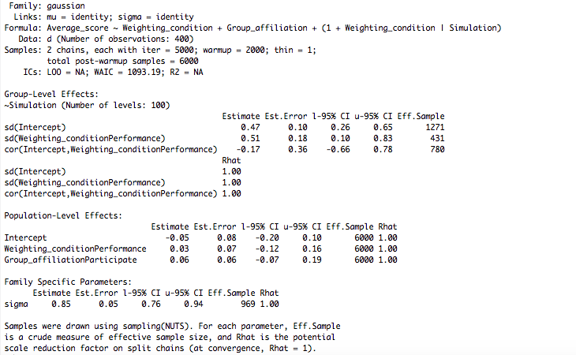

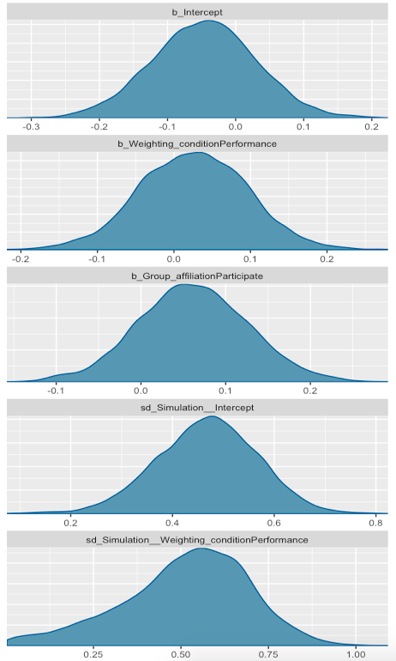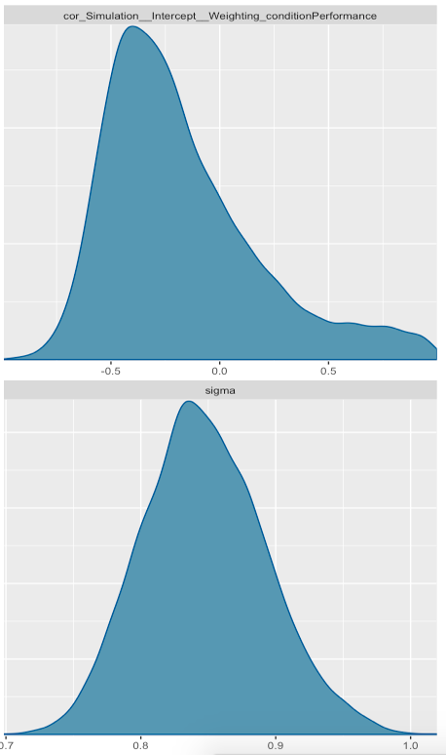

Again it can be seen that there are positive beta estimates, in accordance with the hypotheses. There are large random effects and deviance, and the predictive posterior check yields almost the same results as before.

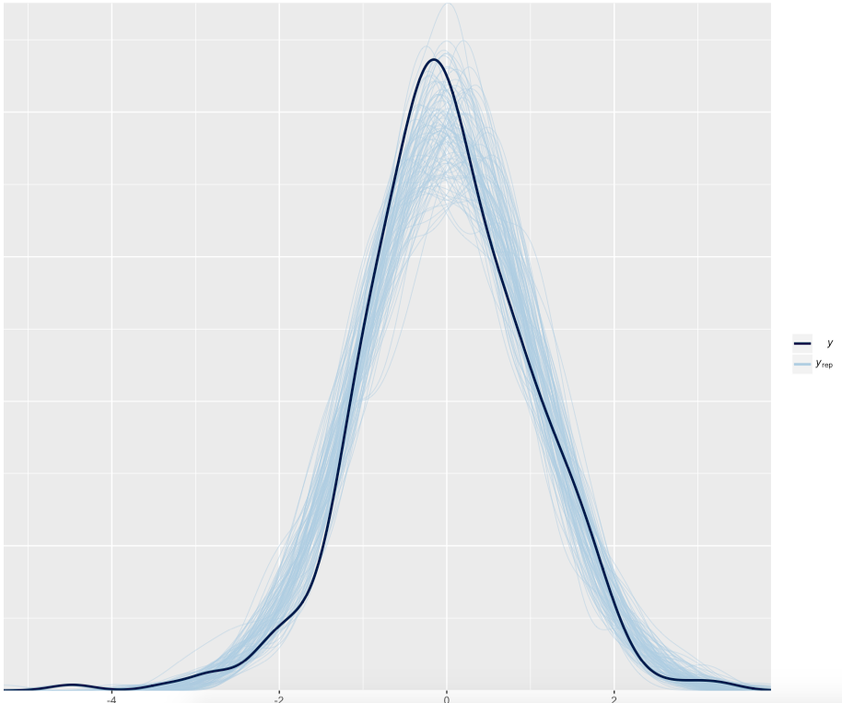

### Strict simple model

Numerical output and plotted estimate distributions for the strict model without interaction:

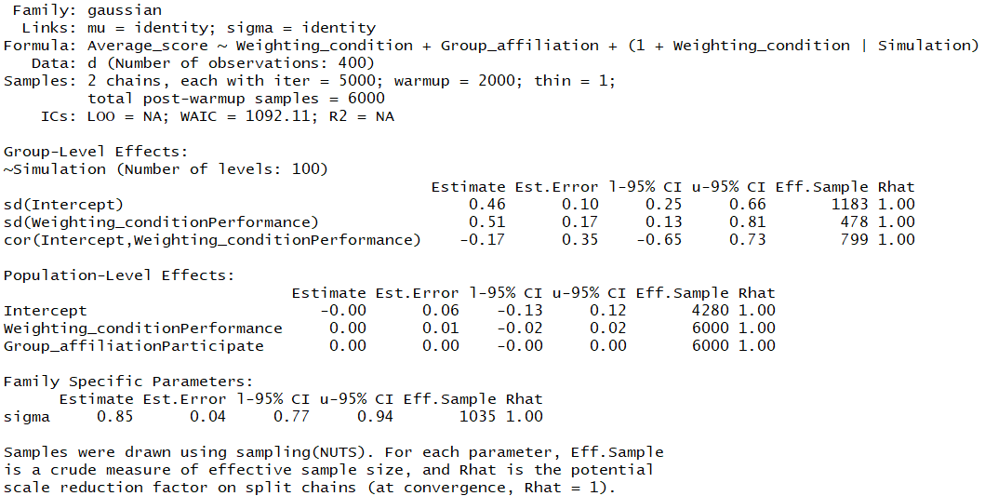

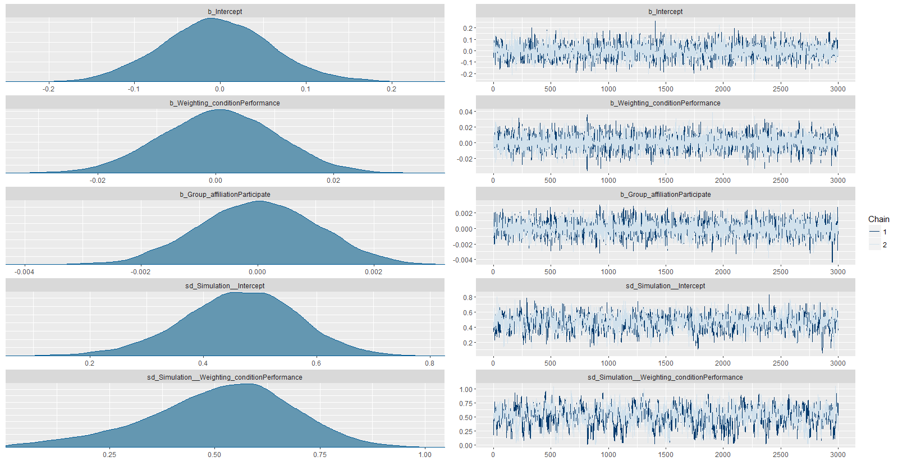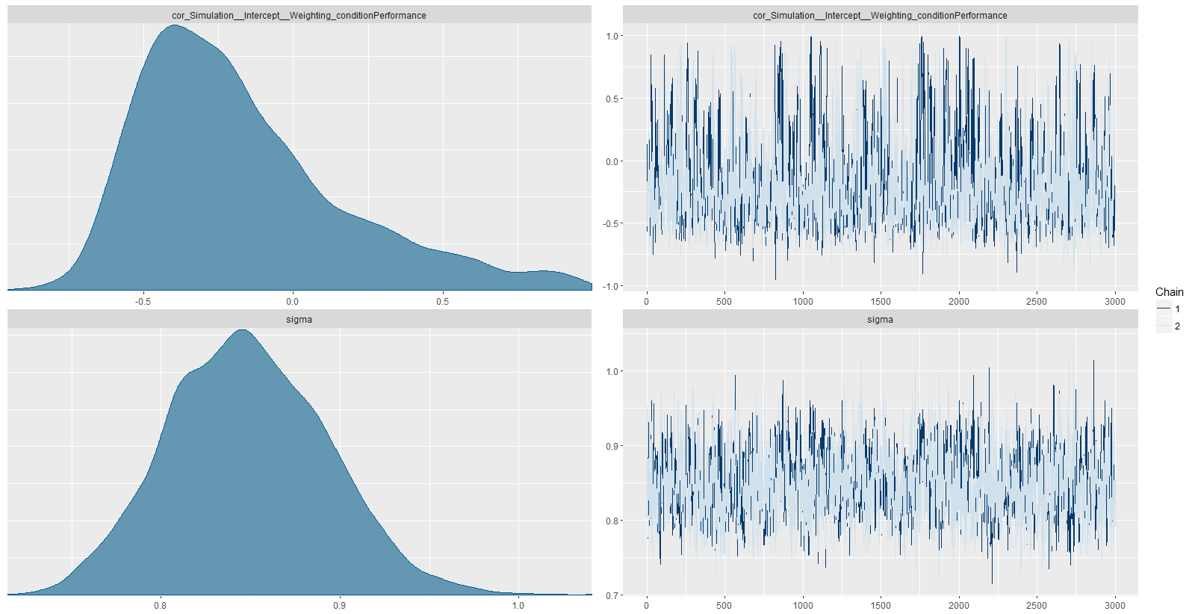

It can be seen how estimates are now again centred around 0, with large random effects and error. The predictive posterior check still gives results approximately identical to other models

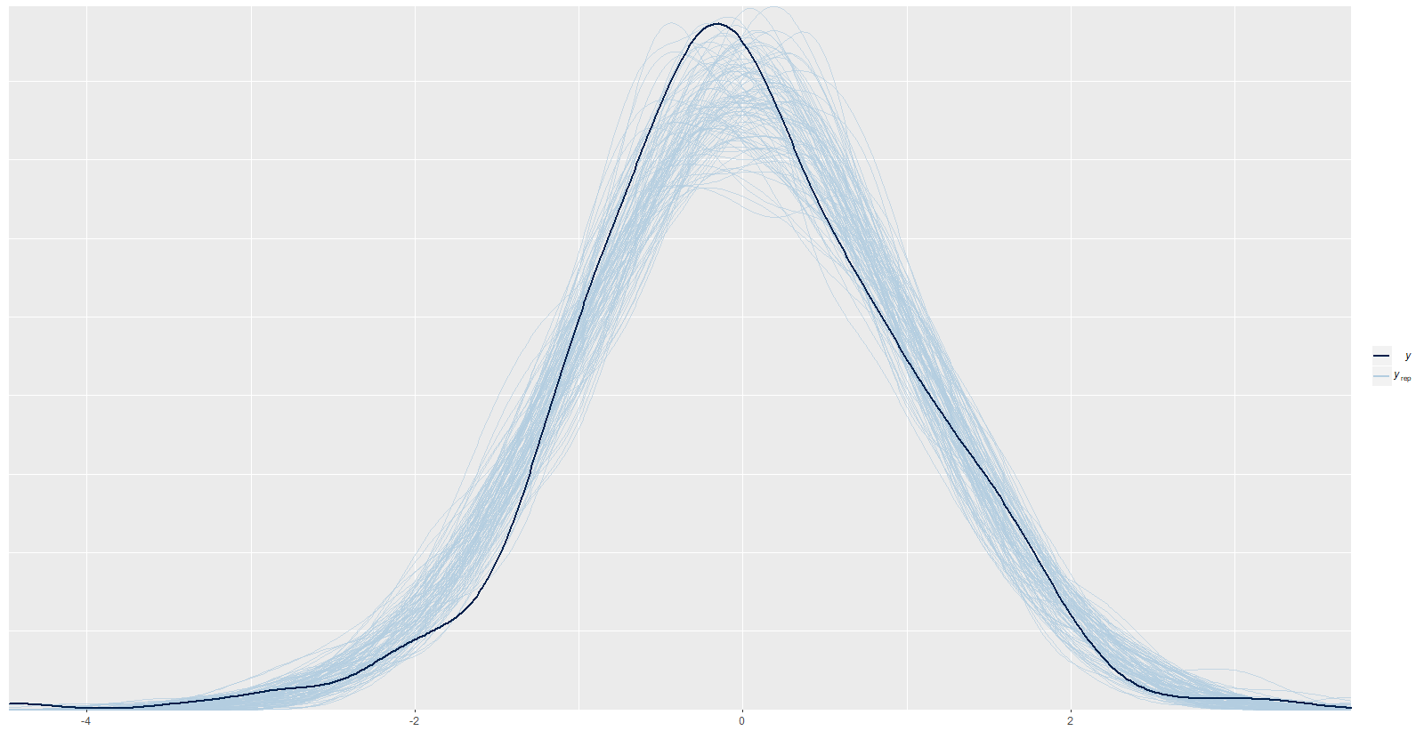

## Comparing Models

The WAIC values of all four models are almost identical – their relative size determined only by random inter-simulation differences - and the predictive posterior checks are indistinguishable, meaning that it is not possible to determine which model performs best.

Below are plots of the beta estimates’ priors (black) and posterior distributions of the simple (green) and full (blue) models.  
To the left is the loose model, to the right the strict model:

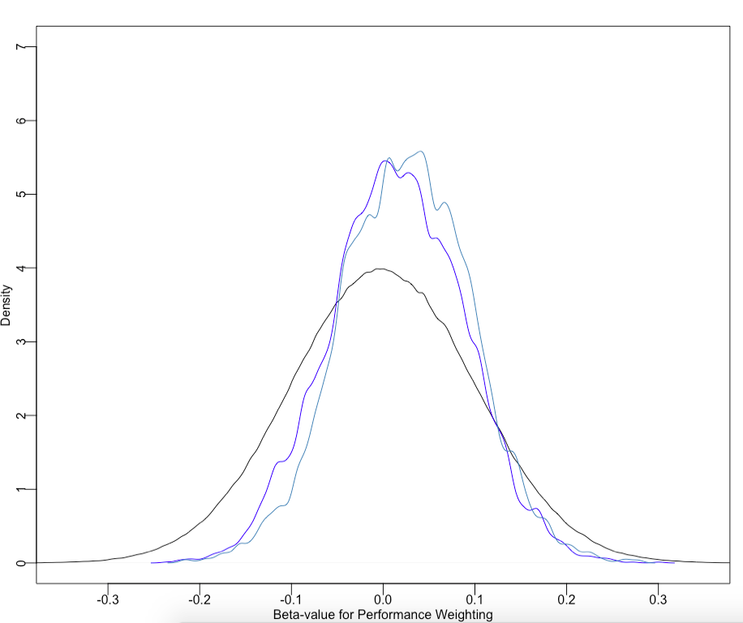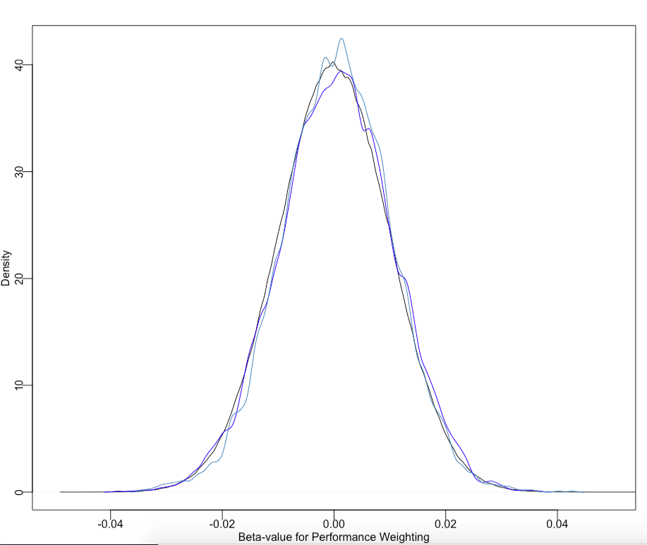

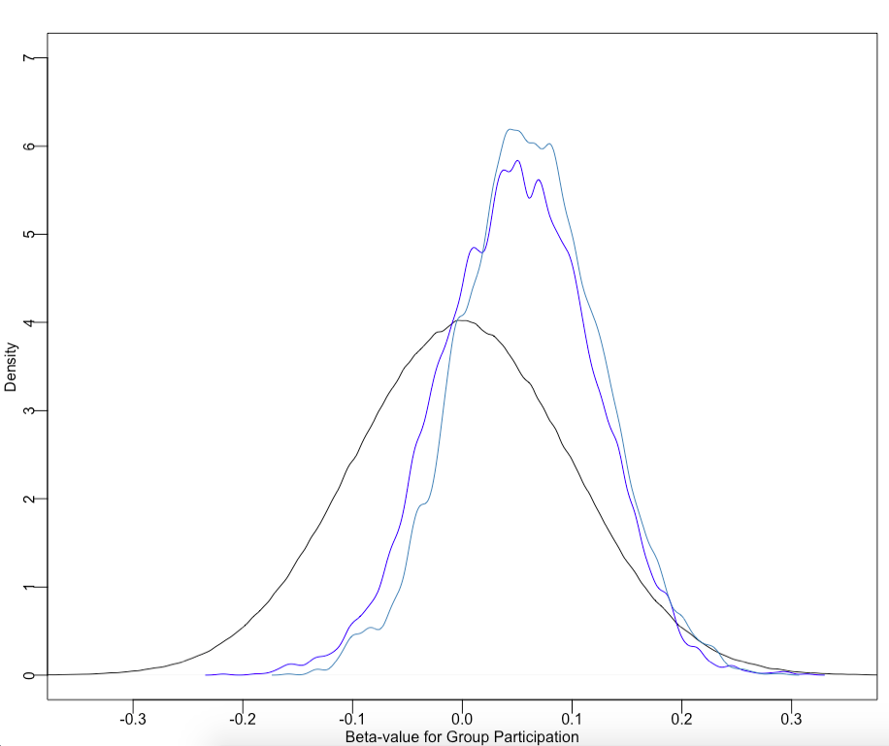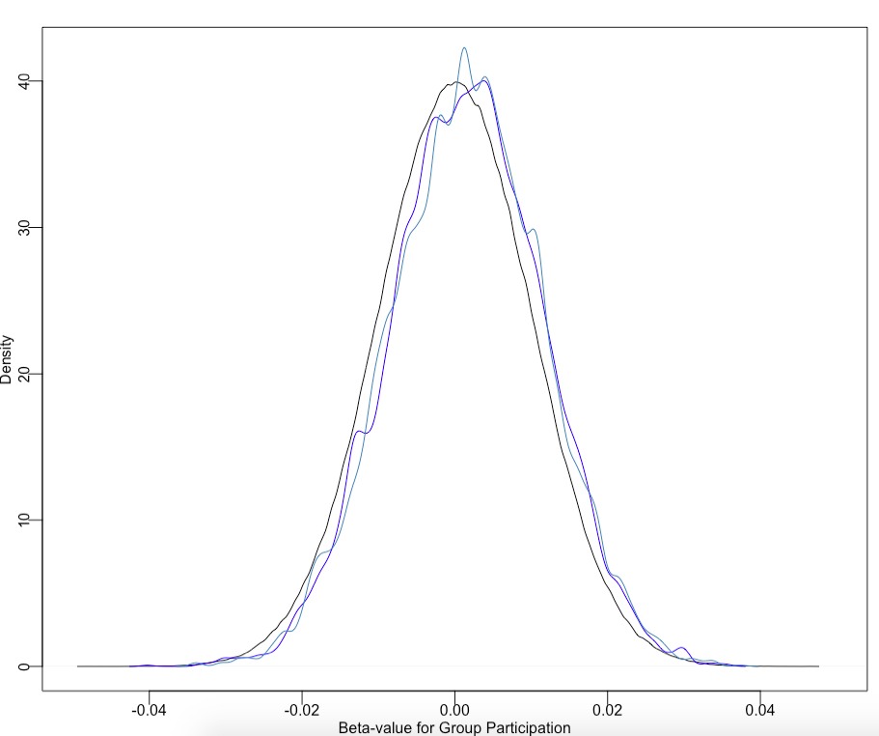

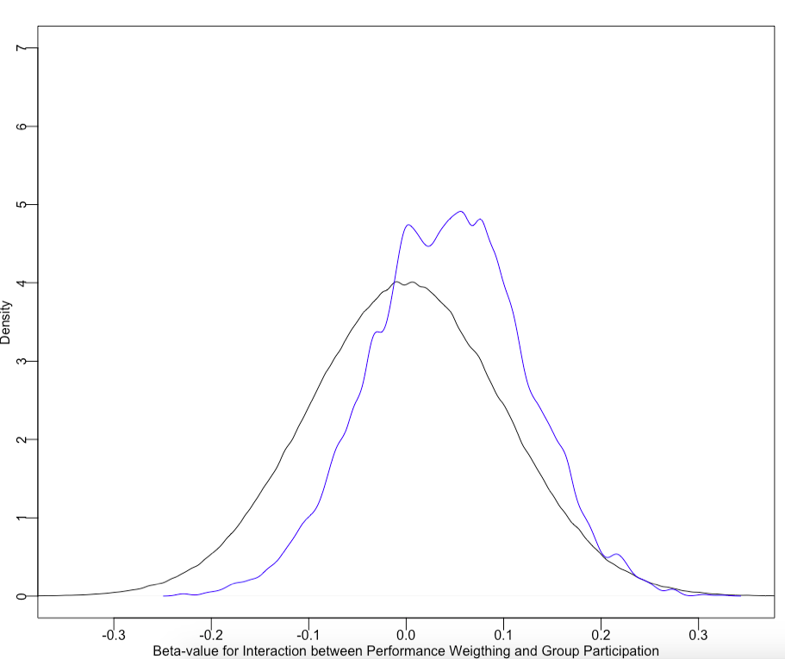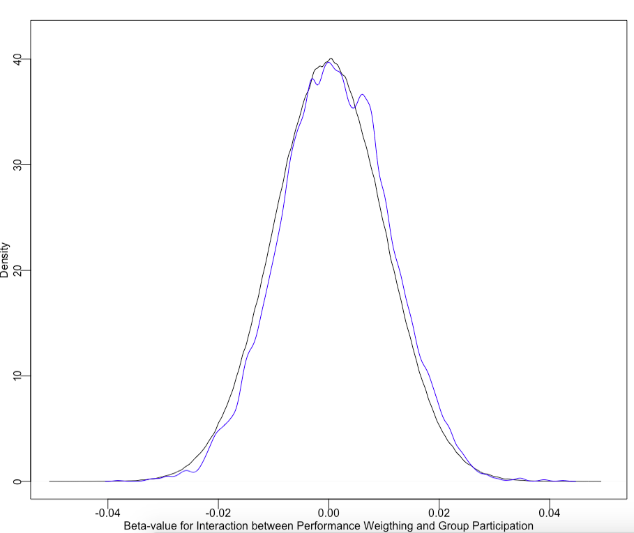

And finally them all plotted together:

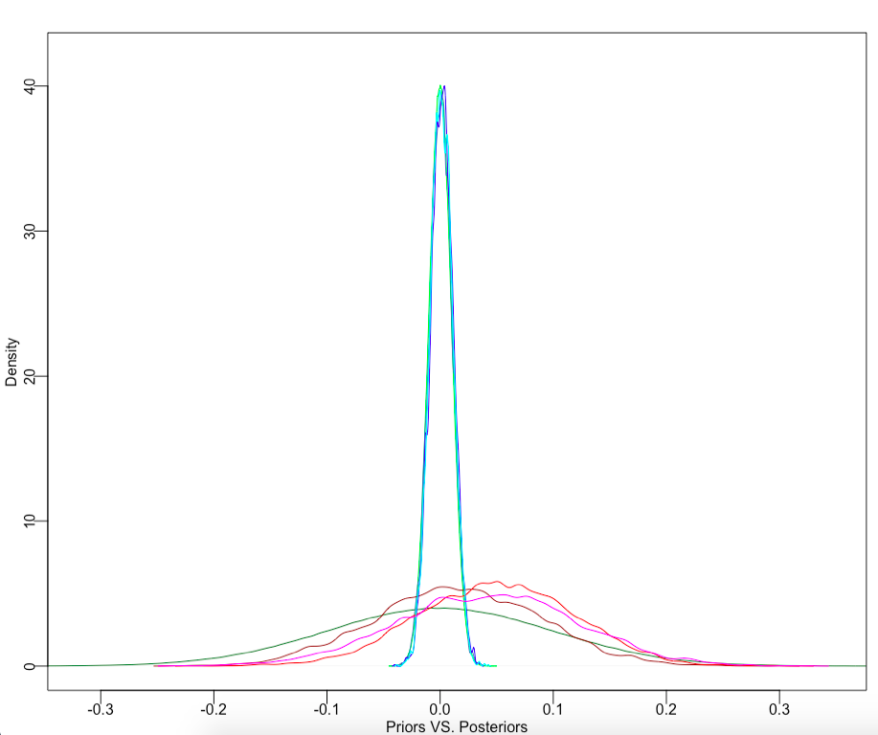

It can be seen that the sceptic prior overwhelms the likelihood – the prior and the posterior are almost identical. Thus there is not enough data and a so weak effect that it is not robust to a very conservative prior, and as such, we do not learn much from the analysis.  
On the other hand, there is a clear trend in the movement of the posteriors, all in accordance with the hypotheses. The same trend is even visible when the priors are strict, albeit very slightly.   
Thus it would seem that the hypotheses can be supported – but a rerun of the simulation with many more data points should be run (We didn’t have the time this time). It is also a possibility to use data from every trial of every simulation, instead of the mean of the scores across all trials for each simulation.   
It is also a possibility to use steeper logistic functions in the conversion of deck choices into performance weighting strength, thus letting the weighting have greater impact on the group choices. It is possible that the reason we are seeing so slight an effect is simply because the weighting is so slight that its effect is not visible.

Finally, below is a plot of the raw data:

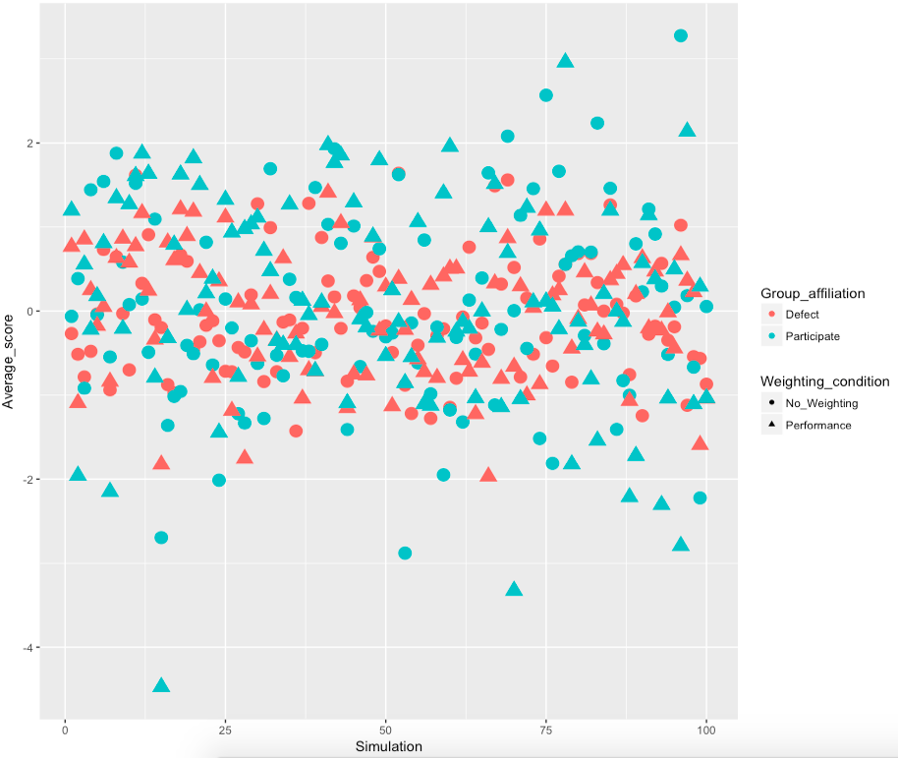

Here it can be seen that it is difficult to make out if there is a higher score when participating (green) and performance weighting (triangle shape). This is because the estimated effect is of such a low scale, compared to the sizes of the data values.  
There is a larger variation for the group decisions, which naturally arises from the fact that everyone in the group makes the same decision – making the mean more volatile.  
There is generally a large spread across simulations, pointing to some kind of sensitive dependence in the simulation, either based on the sampled learning parameters of the agents, or of the specific combinations of agent choices. Sensitive dependence would also make finding a single effect difficult – the effect might be different for different starting conditions.

Github Links: